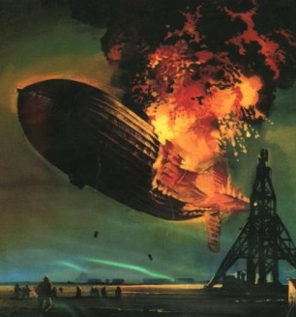

**Chronological**

**Sub-headings**

**The Hindenburg disaster**

**Summarise importance**

**Written in the third person**

**Past tense**

**Adjectives**

**Specific facts**

**Statistics**