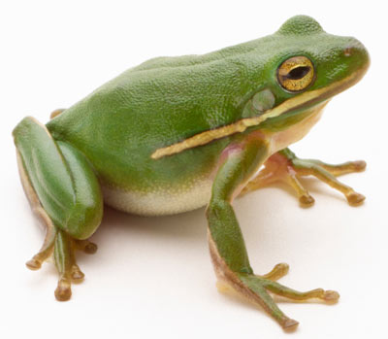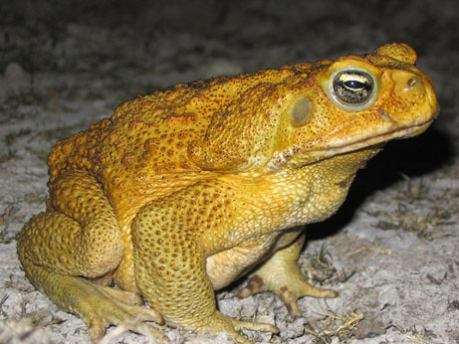
Frogs
Toads
A
B
C
D
E
F
G
H
I
J
K
L
M
N
O
P
Q
(R)
Appearance
Actions
Reproduction
Anatomy

(E)
(F)

